keywords (Times New Roman Italic 10,

respect the right margin adjustment)

Instructions for preparing an abstract for ICCMR16 (Times New Roman 14)

A. Author^{1*}, B. Author² and C. Author³
¹Full address of A. Author
²Full address of B. Author
³Full address of C. Author
(*) e-mail@corresponding.author
Introduction (Arial Bold 12)
The Local Organizing Committee and the International Organizing Committee have the pleasure to invite you to participate in the 16th International Conference on Catalysis in Membrane Reactors (ICCMR16) which will be held on October 16th – 18th, 2023 in Donostia-San Sebastián (Spain). The ICCMR16 will be organized by TECNALIA (Times New Roman 12).
Experimental (Arial Bold 12)
To meet the editing requirements, we kindly ask the authors to send two abstract pages, written in English, until May 31st 2023.
It is strongly recommended to use this template, by inserting your text in the corresponding lines of the template, to achieve the required styles, formats and spacing.
The abstract of your presentation should be written with MS Word text editor using Times New Roman with single spacing between the text lines. It should not be longer than two A-4 pages.
Please note, that each element of the text has an individual style. Use the exact styles presented in the template.
Results and discussion (Arial Bold 12)
If the keywords occupy less than three lines, please leave empty lines, using the end of line mark (enter) with 10 font size.
In case of various affiliations, numbers ¹; ²; ³…. should be added after the name of each author. Corresponding author should include symbol * in addition to the affiliation number.
Figures should be 7 cm in width. The legend (axis descriptions, numerical values) should be written using Times News Roman 10 font. Information about the font size refers to the figures reduced to 7 cm in width. Figures can be positioned one under the other or two at the same level (see the example below).

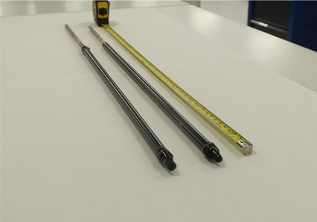
Fig. 1. Description of figures positioned at the same level should be placed as two-column text

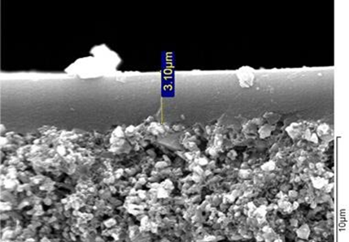
Fig. 2. Spacing between columns is 0.5 cm (Times New roman 10).

Important dates are indicated in Table 1.

Table 1. Fonts and spacing in tables should be the same as in the main text
Date | Event
1st January 2023 | Opening Abstract Submission
15th July 2023 | Deadline for Abstract Submission
25th July 2023 | Abstract Notification

Conclusions (Arial Bold 12)
Include conclusion here.

Acknowledgment (Times New Roman Bold 10)
Indicate the source of financial support (Times New Roman Italic 10)
References (Times New Roman Bold 10)
[1] J. van der Geer, J.A.J. Hanraads, R.A. Lupton, The art of writing a scientific article, J. Sci. Commun. 163 (2000) 51-58
[2] W. Strunk Jr., E.B. White, The Elements of Style, third ed., Macmillan, New York, 1979
[3] G.R. Mettam, L.B. Adams, How to prepare an electronic version of your article, in: B.S. Jones, R.Z. Smith (Eds.), Introduction to the Electronic Age, E-Publishing Inc., New York, 1999, pp. 281-304
[4] C. Radhusvej, G. Xiao, WO 99/24383 Methane oxidation to methanol

Do not convert text to “pdf” before submitting! Submit text as MS Word document.

